Your Research Question:
How does the presence of heavy metals, specifically copper and lead, affect Hemigrapsus nudus physiology?

Your Hypothesis:
Hypotheses:
- H0: There will be no change in hemocyte count across all groups.
- HA: There will be an impact on the total hemocyte count (THC) in the trace metal experimental groups.
  - HA1: THC will increase (immune activation)
  - HA2: THC will decrease (immune suppression)

- H0: There will be no change in righting time across all groups.
- HA: Increase in righting time (stress response) in the trace metal experimental groups.

- H0: There will be no change in osmolality across all groups
- HA: There will be an increase in osmolality in the trace metal experimental groups

Key figure(s):

- This should include any figures you plan on including in your final paper
  - Righting time across weeks for different treatments (julia)

  - Osmolality across weeks for different treatments (Maria)
    - H. nudus are active osmoregulators
  - Possibly hemocyte counts (only have one week but we do have enough data to make a graph)-Eliza

- Rubric element for final paper indicates what we expect: "Figure is well chosen given the data, axes and title are labelled appropriately, use of color highlights differences between treatments."

Your key takeaway for each figure / result:

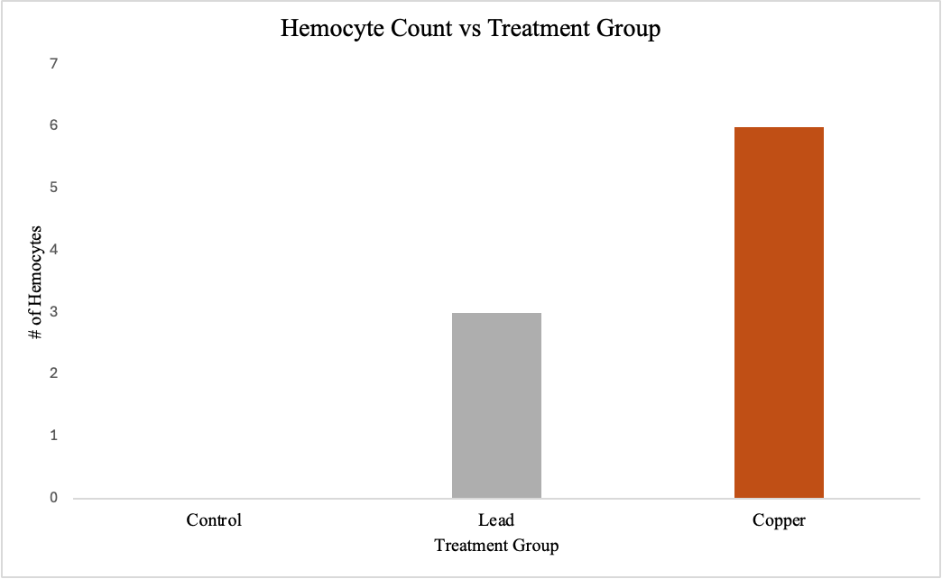
Figure 1: Bar graph showing hemocyte counts in crabs across different treatment groups; control, lead, copper. No hemocytes were found in the control group for week 3, but were present in the lead and copper treatment groups. This would suggest that the crabs' immune systems were active in the lead and copper treatments, resulting in an increase in the number of hemocytes present in their hemolymph.

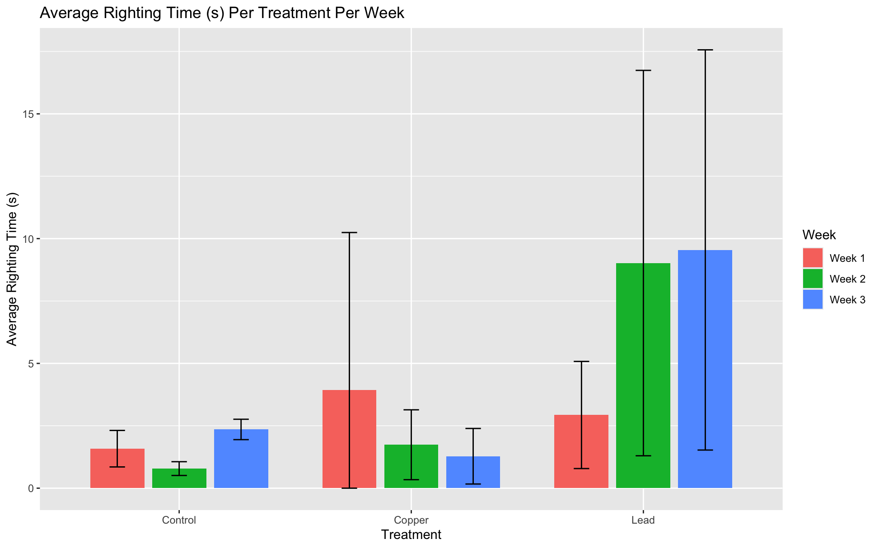
Figure 2. Bar graph depicting average righting time (s) per treatment (Control, Copper, Lead) per week (Weeks 1, 2, and 3). Stable righting time in control group with little standard deviation. Decreased average righting time in copper treatment indicates decreased physiological stress while increased righting time in lead treatment indicates increased physiological stress.

Key Takeaway Figure 2: Relatively fast righting times in each control group per week. Average righting time per week in the copper treatment decreased indicating a lack of physiological stress in this group. Lastly, average righting time per week in the lead treatment increases, indicating high physiological stress.

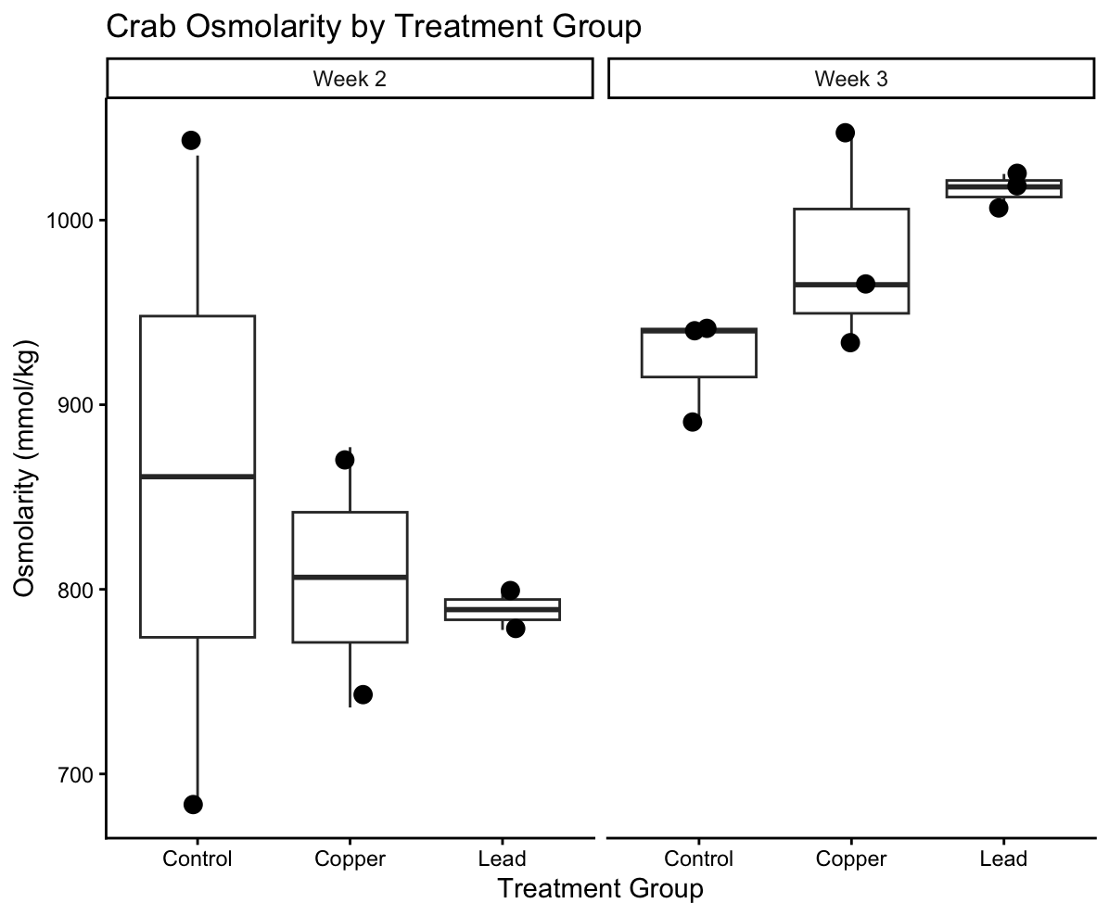
Figure 3. Osmalality (mmol/kg) of crabs exposed to Control, Lead and Copper treatments during Week 2 and 3. Each point represents an individual crab and the boxplot shows the distribution of osmolality values within each treatment group.

Key take away: Osmolality appears to increase with prolonged exposure to metal treatments, particularly copper, which suggests the crabs may be experiencing stress and having to work harder to maintain internal ion and water balance.

https://pmc.ncbi.nlm.nih.gov/articles/PMC8082544/
“Crustaceans usually have to compensate for the influx of ion through hypo-osmoregulation whenever the osmolality of the environment is hyper-osmotic to the haemolymph osmolality (Rainbow and Black, 2001). When the osmolality of the haemolymph is however, hyper-osmotic to the environmental osmolality, it compensates for the loss of ions from the haemolymph by hyper-osmoregulation”
“Crabs are capable of taking up and accumulating trace metals in their tissues and are, therefore a suitable bioindicator for environmental contamination assessment”

https://www.sciencedirect.com/science/article/pii/S1532045616300382
“To maintain salt balance, ions are actively captured by ion transporting pumps like the gill Na⁺/K⁺-ATPase (McNamara and Faria, 2012), which also increases the uptake of metal ions of similar size and charge (Nugegoda and Rainbow, 1989, Rainbow, 1996). Such increased metal uptake can impair hyper-osmotic regulatory ability “
“ U. rapax from chronically contaminated localities can adjust its osmoregulatory abilities in winter and inhabit stressful contaminated environments characterized by daily changes in salinity. In summer, the crabs appear to be unable to provide additional energy for efficient ionic regulation. “
“Metals in the environment can compete with other ions such as Na⁺ (Grosell and Wood, 2002, Rainbow and Black, 2002) and Ca² ⁺ (Paquin et al., 2000, Gensemer et al., 2002) by binding to physiologically active sites in the gill cells, consequently being incorporated by the organism. The Na⁺/K⁺-ATPase is involved in metal transport across the gill epithelium (Handy and Baines, 2002), and metals can increase enzyme activity by a hormetic effect (Calabrese and Baldwin, 1997), resulting in better osmoregulatory capability. “

https://pubmed.ncbi.nlm.nih.gov/16806525/

https://pubmed.ncbi.nlm.nih.gov/22115908/
“Osmoconformers are expected to have higher capacity for cell volume regulation, but gill cells of a regulator are expected to display ion transporters to a higher degree. “

High osmolality: Indicates a lack of water (dehydration) or high amounts of solutes like sugar (e.g., in uncontrolled diabetes).
Low osmolality: Can indicate overhydration or water intoxication.
Osmotic stress (or shock) is the physiological strain placed on cells when there is a sudden, significant change in the solute concentration of the fluid surrounding them. It disrupts normal water balance, triggering the following reactions
- Hyper-osmotic stress (High solute concentration): Water rushes out of the cells via osmosis, causing them to shrink, shrivel, and undergo structural deformation. This triggers inflammation and the release of protective proteins.
- Hypo-osmotic stress (Low solute concentration): Water rushes into the cells, causing them to swell, potentially leading to cell rupture (bursting) or apoptosis (cell death)
Osmotic stress occurs when environmental factors (e.g., rapid salinity changes, dehydration) or pollutants alter the crab's internal fluid balance. This triggers physical and biochemical stress responses
- The Stress Mechanism: When osmolality fluctuates too rapidly, neuroendocrine organs release hormones (like crustacean hyperglycemic hormone), mobilizing energy and glucose to deal with the shock.
- Cellular Response: Under low-salinity stress, the crab upregulates specific genes to pump ions. Under high-salinity stress, crabs may produce more free amino acids to match internal/external osmotic levels.
- Energy Drain: Active osmoregulation is energetically expensive. If the osmotic gradient between the crab's hemolymph and the environment is too large, it places a heavy metabolic cost on the animal, often resulting in slowed growth, weakened immune systems, or high mortality

To keep their cells from shrinking or swelling during rapid salinity shifts, crabs flood their bodies with free amino acids (organic osmolytes). This alters their metabolism and can suppress their immune system.

The Impact of Heavy Metals
Heavy metals (like copper, cadmium, lead, and nickel) act as environmental stressors that disrupt a crab's ability to maintain osmotic homeostasis.
- Damage to Gills: Heavy metal accumulation heavily damages the gill epithelia, which are the primary organs for gas exchange and active ion transport.
- Enzyme Inhibition: Metals like cadmium and copper inhibit essential osmoregulatory enzymes, particularly \(Na^+,K^+-ATPase\) in the posterior gills.
- Disrupted Osmolality: This enzymatic and physical damage impairs the crab’s capacity to pump ions (like \(Na^{+}\) and \(Cl^{-}\)) in or out. Consequently, hemolymph osmolality fluctuates dangerously, leading to impaired cellular volume regulation, tissue damage, and cellular swelling

https://sci-hub.st/storage/2024/591/56b5298c2576e0c0170ecf86e0044f6b/thurberg1973.pdf

